

**Coordinators**

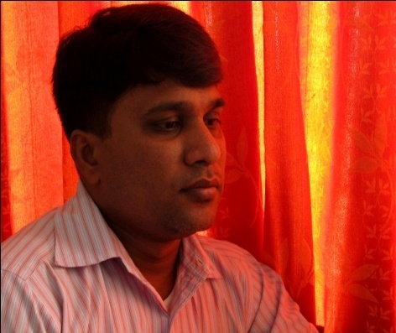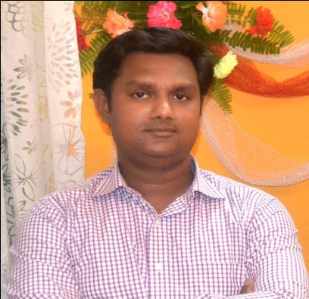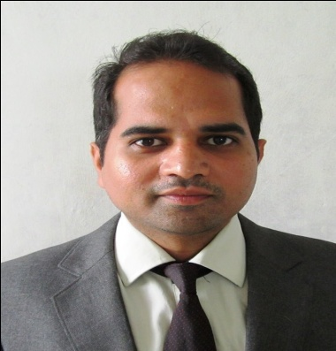

**Prof. L. P. Puranik Prof. A. P. Ogale Prof. S. V. Karankoti**

**(Department of Mechanical Engineering, SIT, Lonavala)**